Guide to Completing Morley College Bursary Fund Application Form

This form is to request financial support with unaccredited course fees. Applications must be made before you enrol on a course. Applications forms submitted after enrolment are not able to be considered.

About the fund
The Morley College Bursary is a discretionary fund operated by the College to assist students who are experiencing financial difficulties and are unable to pay the full course fee.
We welcome applications to the fund and all applicants need to write a statement and attach all evidence of financial. Funds are limited and the College regrets it may not be possible to fund all students who meet the criteria. Students can apply for Bursary support on most courses, but not if Advanced Learner or Higher Education Loans are applicable for the course.
The fund can make a contribution towards course fees of either 25% or 50%.
Support is restricted to £300 per student per year and this can be spread across 3 terms.
You can only get support with one course per term.
Applications must be made before you enrol on a course, application forms submitted after enrolment will not be considered. You may be required to attend an interview to discuss your application.
The Bursary Panel will treat all applications confidentially and you will be informed of the decision via email within 10 working days of the meeting.
The panel compromises of staff whose roles within the college are directly linked to supporting students.
If your application is not granted, you can appeal a decision. This must be done via email to the Head of Student Services, Vusa Nkomo Vusa.Nkomo@morleycollege.ac.uk
You must submit an appeal, within seven days of written notification of the outcome of your application

If you are studying on an accredited course and you would like financial support please email: student.finance@morleycollege.ac.uk

There are a number of steps to complete, please read through these notes and make sure you have everything you need before you start the application.

We ask for your Personal Details
Student Reference Number: If known
Name
Date of Birth
Address
Email
Mobile Phone Number

We ask for the course details that you are asking for support for
Course Code: e.g. WXXXXXX01A, KXXXXXX02B, CXXXXXX03C,
Course Title: e.g. Jazz Piano 1A

We ask for details on your financial circumstances
Please indicate monthly income amounts in the boxes provided. 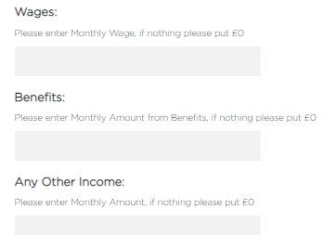

We ask you to upload the supporting evidence of the income mentioned
This can be benefit documents or pay slips. Please make sure you upload documents in full e.g. the full Universal Credit statement not just the first page. Your application will be delayed if you do not attach copies of the documents which support your claim.
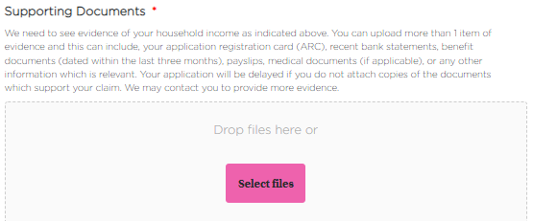

Click Select files and you can upload them
When they are uploaded they will appear in a list below the box
If you have made a mistake, click the red cross to delete and upload again

We ask you for a Supporting Statement
Please tell us why you are applying for a bursary. You should include information on any exceptional circumstances that mean you are unable to cover the fees, and how you feel the bursary will benefit you on your course.

We ask you to agree to the declaration
By entering your full name, as a signature, and putting in the date

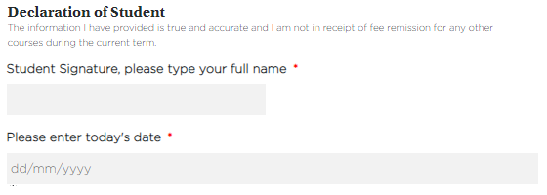

Once you click submit we will receive a copy and we’ll contact you via email after the Bursary Panel meeting, you should hear within 10 working days of submitting
Please contact student.finance@morleycollege.ac.uk with any queries

