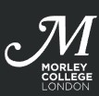
Guide to Completing Free School Meals Application Form
This form is to request support with Free School Meals whilst you are studying.
You must be either:
a) Aged 16-18
- OR 19 if continuing a course of study, you started while 16-18 at Morley
- OR 19-23 with an EHCP

AND enrolled on an applicable accredited course(s).

The allowance is £3.50 per day for the days you are timetabled to attend college, and this allowance can be redeemed at the canteen of the site you are studying at. You can buy whatever you like with the entitlement, but the college hopes that you will select a healthy choice. If you want to spend more than £3.50 on food and drink, you can pay the extra on top of your entitlement. The entitlement is only for the day in question and cannot be transferred, refunded, or saved up. This entitlement will be removed if your attendance is below 90% at any given time, you subsequently abandon or do not complete the programme of learning, or your conduct or behaviour is in breach of college rules and regulations.
There are a number of steps to complete, please read through these notes and make sure you have everything you need before you start the application.

We ask for your Personal Details
Student Reference Number: Your unique 8 digit number will be on your offer letter, if you are unsure you can ask at reception at any centre for it or email student.finance@morleycollege.ac.uk

Name
Date of Birth
Email
Mobile Phone Number

We ask for your Course Details - This information will be on your offer letter.

Course Code(s): If you are studying more than one course please write all the codes, e.g. CXXXXXX01A, KXXXXXXX3C…
Course Title(s): If you are studying more than one course please write all titles in the box

Campus: Please enter the site you are studying at

We ask about previous Free School Meals
Did you receive Free School Meals at School?
Please indicate No or Yes in the box below and enter which years if Yes

You need will to provide proof of benefits and upload evidence to support your application
Your parent or guardian must be in receipt of one of the following benefits. You may also be eligible if you get paid these benefits directly, instead of through a parent or guardian -
- Evidence of Free School Meal eligibility from previous school or local authority for the academic year 23/24
- Income support
- Income-based Jobseekers Allowance
- Income-related Employment and Support Allowance (ESA)
- Support under part VI of the Immigration and Asylum Act
- The guarantee element of State Pension Credit
- Child Tax Credit (provided that you are not entitled to Working Tax Credit and have an annual gross income of no more than £16,190, as assessed by HMRC
- Universal Credit - if you apply on or after 1 April 2018 your household income must be less than £7,400 a year (after tax and not including any benefits you get)

You will need to upload a photo/scan/PDF of benefit evidence as ticked above. It MUST be recent, dated within the past 3 months. If your proof is older than that, you will also need to upload a recent bank statement showing the benefit being paid.
For Universal Credit you must provide statements from the three most recent complete assessment periods, showing earnings if applicable
Click ‘Select files’ and to upload them to the site.

Please make sure you upload documents in full e.g., the full Universal Credit statement not just the first page. Your application will be delayed if you do not attach copies of the documents which support your claim.

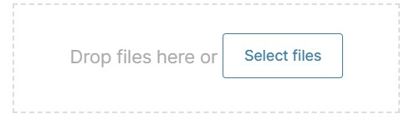

If you have made a mistake, click the red cross to delete and upload again.
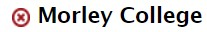

We ask you to agree to the declaration
Read and tick all boxes then type your full name as a signature, and today’s date.
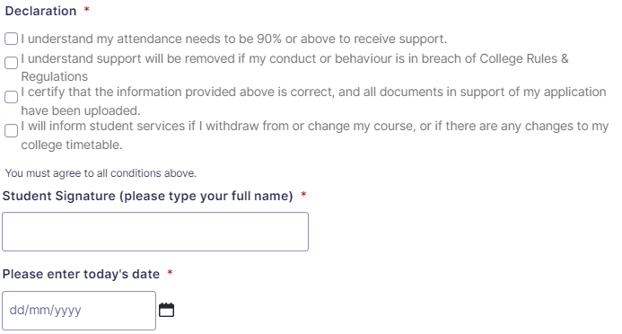

After you click Submit we will contact you to confirm your eligibility.
Please contact student.finance@morleycollege.ac.uk with any queries.

