Guide to Completing 16-18 Bursary Fund Application Form

There are two types of Bursaries available, and you only need to apply for one

- The Vulnerable Bursary is for students who are in care, care leavers, receiving Universal Credit and living independently or receiving Personal Independence Payments as well as Universal Credit in your own right.
Eligibility: You must be over 16 but under 19 on 31st August. You must be enrolled on an applicable accredited course(s). Your application will not be assessed without the correct evidence, which you will be asked to upload.

- The Discretionary Bursary is for students who are dependent on someone in receipt of a means tested benefit or on low income (less than £25,642.50 per year.)
Eligibility: You must be aged 16-18 on 31st August, 19 or over and continuing on a study programme you began aged 16 to 18 at Morley or 19-23 and have an EHCP. You must be enrolled on an applicable accredited course(s). Your application will not be assessed without the correct evidence, which you will be asked to upload.

Please note, funds are limited and eligibility for the fund does not guarantee a grant will be made

The Bursary is awarded if your attendance is 90% or above at any time, you can check this on e-trackr or MyDay when you are in college.

There are a number of steps to complete, please read through these notes and make sure you have everything you need before you start the application.

We ask you to pick which one you are applying for
Please select one box only
Vulnerable Bursary
Discretionary Bursary

We ask for your Personal Details

Student Reference Number: This is your unique 8-digit number and it will have been emailed to you by the IT team and forms part of your Morley email address e.g. 01110078@morley.ac.uk. Alternatively, you can bring ID and ask reception at any centre for it. If you received an offer letter it will be on that.

Name
Date of Birth
Address
Email
Mobile Phone Number

We ask for your course details - This is for your main course with the college, if you are also studying English and/or Maths we'll assess this as part of your application.

Course Code: e.g. KXXXXXX02B, CXXXXXX03C, Course Title:
Campus:

We ask you to tick the days that you study

We ask for evidence for Vulnerable Bursary ONLY to be uploaded first –
If you are in care or a care leaver, please upload a letter confirming your status from your local authority. If you are receiving Universal Credit in your own right because you are financially supporting yourself, please upload a Full Monthly Universal Credit Statement with your name and address AND a document such as a tenancy agreement in your name. If you are receiving Universal Credit in your own right because you are financially supporting yourself AND receiving Disability Living Allowance (DLA) or Personal Independence Payments (PIP), please upload a Full Monthly Universal Credit Statement with your name and address AND your evidence of DLA or Pip AND a document such as a tenancy agreement in your name.

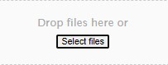

If you are applying for the Vulnerable Bursary once you have uploaded your evidence above, please skip to the Bank Account Information section

If you are applying for the Discretionary Bursary for Travel and Materials we need to know about your household circumstances. Please answer all of the following questions, the answers go towards determining your eligibility for the fund.
All information provided in this section will remain confidential. Please provide full details of what money you receive each month and upload any relevant documents to support what you are saying. E.g. bank statements, benefit letters. Proof of expenditure may be requested. Income should be for the whole household

We ask what you are applying for
Travel & Materials
Materials only (I will be using free TFL travel)
Travel only

We ask about your Oyster Photocard - please do this before applying for the bursary
I have a 16+ Zip Oyster Photo Card (you can have this aged 16, 17 AND 18 - see details below)
I have an 18+ Student Oyster Card
I don't have / not eligible for either of the above

If you are aged 16-17, please apply for a 16+ Zip Oyster photo card.
If you are aged 18 on 31st August and you live in a London Borough you can still apply for the 16+ zip oyster card as you will be in full time education. You’ll need to apply online in your own name and when prompted add in the college name. You will need to download and print a verification letter to take to college, which we’ll sign and stamp you’ll need to take to a post office along with proof of age and address to get your photo card. Please apply at: tfl.gov.uk

We ask for details on your financial circumstances

Number of adults (over 18) in the household
Number of dependants (under 18) in the household including yourself
Annual Income

Please indicate monthly income amounts in the boxes provided.
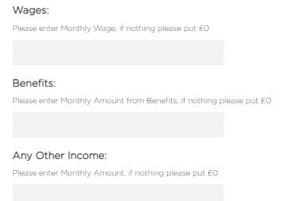

We ask the type of evidence you are going to upload

We ask you to upload the supporting evidence of the income mentioned
This can be benefit documents or pay slips. Please make sure you upload documents in full e.g. the full Universal Credit statement not just the first page. Your application will be delayed if you do not attach copies of the documents which support your claim.
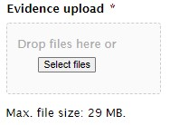

Click Select files and you can upload them
When they are uploaded they will appear in a list below the box
If you have made a mistake, click the red cross to delete and upload again

We ask you to complete the Bank Account Information Section
We need your bank details in order to pay you any bursary funds awarded.
The bank account MUST be in the student's name - a basic bank account can be opened once you are 16.
If you do not have a bank account in your name please open one before submitting an application. Please make sure the details you enter are correct.

Bank Name
Account Name - This account must be in the student's name Bank Account Number
Sort Code.

We ask you to agree to the declaration
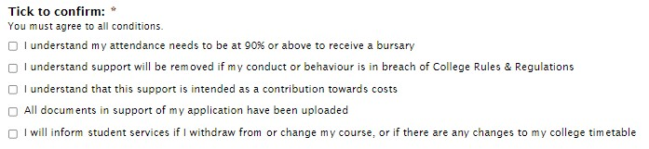

Sign and date

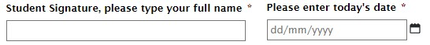

Please contact student.finance@morleycollege.ac.uk with any queries

