Guide to Completing RFSA Bursary Application Form
The RFSA (Royal Female School of Art) bursary fund is only for the tuition fees, travel, and materials on selected Visual and Digital Arts courses at the Morley College Waterloo Centre. Any other associated costs are excluded from this bursary scheme. Please contact student.finance@morleycollege.ac.uk for information on any other bursary funds available for Morley students.
Once you submit this form, it will be sent to your tutor for a supporting statement – all bursary awards must be approved by your tutor and the Head of School. Funds are limited and eligibility for the fund does not guarantee a grant will be made.
Any bursary awarded towards tuition fees will be automatically added to your course, and any bursary for travel and materials will be paid directly to you. The Student Finance Team will contact you about the amounts and when you can expect to be paid.
There are a number of steps to complete, please read through these notes and make sure you have everything you need before you start the application.
We ask for your Personal Details
Student Reference Number (your unique 8 digit number will be on your offer letter, if you are unsure you can ask at reception at any centre for it or email student.finance@morleycollege.ac.uk)
Name
Date of Birth
Sex
Ethnicity
Disability or Learning Difficulties
Address
Email
Mobile Phone Number

We ask for your Course Details
Course Code(s): If you are studying more than one course please write all the codes, e.g. W22XXXX01A, W22XXXX3C…
Course Title(s): If you are studying more than one course please write all titles in the box.

You can find this information on the Morley website, or on your course offer letter.

We ask for details on your financial circumstances
Please indicate amounts in the boxes provided.
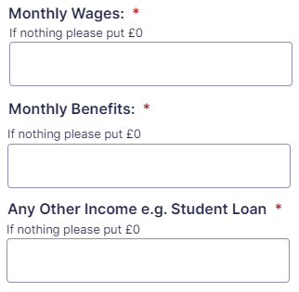

Supporting Documents
You will need to upload a photo/scan/PDF of benefit evidence as indicated above. It MUST be recent, dated within the past 3 months. If your proof is older than that, you will also need to upload a recent bank statement showing the benefit being paid.
You can upload more than one document as evidence and can include recent bank statements, benefit letters, benefit award statements, payslips (dated within the past 3 months), or medical documents (if applicable).
If applying for specific help with travel / materials please attach any receipts.
Your application will be delayed if you do not attach copies of any documents to support your claim.
Click ‘Select files’ and to upload them to the site.

If you have made a mistake, click the red cross to delete and upload again.

We ask some questions to support your application
- about household situation,
- further study,
- employment,
- barriers to learning,
- and any further information.

If you are applying for the bursary for materials / travel, we need your bank details
Any bursary for travel / materials will be paid directly to you.
We need your
- Bank name
- Your name as on the account
- Bank account number (8 digits)
- Sort code (6 digits, e.g. 11-22-33)
Please ensure these details are correct or payments may be delayed.

We ask you to sign a declaration
Type your full name as a signature and today’s date.

After you click Submit we will pass the form over to your tutor for a supporting statement.
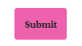

Please contact student.finance@morleycollege.ac.uk with any queries.

